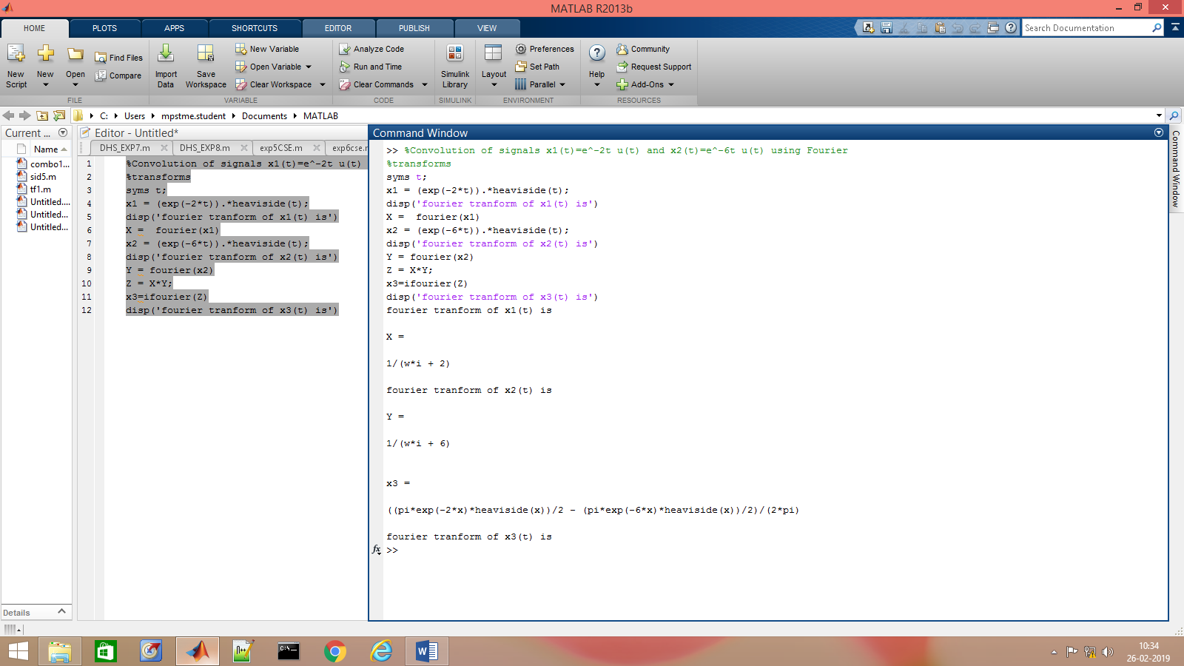

%Convolution of signals x1(t)=e^-2t u(t) and x2(t)=e^-6t u(t) using Fourier

%transforms

syms t;

x1 = (exp(-2\*t)).\*heaviside(t);

disp('fourier tranform of x1(t) is')

X = fourier(x1)

x2 = (exp(-6\*t)).\*heaviside(t);

disp('fourier tranform of x2(t) is')

Y = fourier(x2)

Z = X\*Y;

x3=ifourier(Z)

disp('fourier tranform of x3(t) is')

